Transit Deserts and Transport Equity in the Dublin Region
A GTFS-Based Multimodal Accessibility Analysis of the Post-BusConnects Network, with a Multi-Purpose (Employment, Healthcare, Education) Extension
Bubuya Zelembu Dube
Civil & Railway Engineer | MSc Railway Engineering (Distinction)
August 2026
Independent research analysis. Not affiliated with, commissioned by, or reviewed by Transport for Ireland, the National Transport Authority, or Dublin City Council. See the Publication-Readiness Appendix for methodological caveats prior to any formal citation.

Table of Contents
Table of Contents 2
Executive Summary 3
1. Introduction & Study Area 3
2. Literature Review 3
2.1 The Transit Desert Concept 3
2.2 Ahern, Vega & Caulfield (2016) 4
2.3 NTA Transport Equity / Logsum Study (2025) 4
2.4 First/Last-Mile Accessibility (Oeschger, Carroll & Caulfield, 2023) 4
2.5 South Dublin County Council Accessibility Review (2016) 4
2.6 GTFS as Open Transport Data Infrastructure 4
3. Research Gap 4
4. Methodology 5
4.1 Overview 5
4.2 Data Sources and Provenance 5
4.3 Network Construction 5
4.4 Accessibility Computation 6
4.5 Transit Desert Classification: Formal Definition 6
4.6 Sensitivity to Classification Threshold 6
4.7 Spatial-Statistical Validation 7
5.5 Spatial Clustering Validation 8
5. Results: Employment Accessibility 9
5.1 Overall Classification 9
5.2 Underlying Variables 12
5.3 Equity Statistics: Significance and Effect Size 14
5.4 Electoral Divisions with 100% Desert Classification 14
6. Multi-Purpose Accessibility Extension: Healthcare and Education 15
6.1 Method 15
6.2 Results by Category 15
6.3 Compounding Disadvantage 15
7. Site-Specific Narratives 18
7.1 Priorswood (Dublin City, Coolock area) 18
7.2 Dún Laoghaire–Sandycove / Glenageary (Dún Laoghaire-Rathdown): A Last-Mile Case 18
7.3 Kimmage (Dublin City) 18
7.4 Balbriggan Rural (Fingal) 18
8. Discussion 19
9. Limitations 20
10. Conclusion & Recommendations 21
Appendix: Publication-Readiness Checklist 22
References 23

(Right-click and select “Update Field” if this table appears empty — it is a live Word field, not static text.)

Executive Summary
This study presents an open, reproducible, GTFS-based transit accessibility and “transit desert” analysis of the Dublin Region's current public transport network. Using Transport for Ireland's live static GTFS feed, CSO Census 2022 Small Area data, the Pobal HP Deprivation Index, and OpenStreetMap facility data, the analysis identifies where a genuine mismatch exists between transit need and transit supply — rather than mapping low accessibility in isolation — following the demand-supply framework established by Jiao and Dillivan (2013).
Applying this framework to employment accessibility, 854 of 4,926 classifiable Small Areas (17.3%) are identified as transit deserts under a median-split classification, representing an estimated 233,825 people (16.6% of the classifiable population). This headline figure is threshold-dependent: a stricter top/bottom-quartile definition yields 105 Small Areas (2.1%); the classification's most severe cases (the top 15 by severity index) remain classified as deserts under every threshold tested. A Global Moran's I test confirms the desert pattern is genuinely, strongly spatially clustered rather than randomly distributed (I = 0.679, p = 0.001), and Local Moran's I analysis identifies 869 Small Areas (17.6%) as members of statistically significant desert clusters — including 100% of Priorswood's Small Areas. A statistically significant association was found between desert status and area-level deprivation (χ² = 214.5, p < 0.001, Cramér's V = 0.21, a small-to-moderate effect), indicating that transit deserts and income deprivation are related but distinct phenomena.
Extending the analysis to healthcare and education destinations — addressing a gap in the existing Dublin literature, which has focused on employment accessibility alone — 491 Small Areas are classified as transit deserts across three or more destination categories simultaneously, and 133 across all four categories tested (employment, healthcare, schools, third-level education). This compounding-disadvantage pattern spans all four Dublin local authorities, not only Dublin City.
Several Electoral Divisions show 100% of their constituent Small Areas classified as employment-access transit deserts, including Priorswood B/C/D, Kimmage A/B/D, Kilmore B/C, Cherry Orchard A, and Crumlin E, all in Dublin City. A secondary finding, surfaced during spatial validation, shows that areas with strong rail (DART) trunk service can still register as transit deserts where the specific destination requires an additional last-mile transfer — indicating that trunk-line proximity alone does not guarantee door-to-door accessibility.
This analysis extends Ahern, Vega and Caulfield's (2016) study of deprivation and access to work in Dublin — the closest prior academic precedent identified in a targeted literature search — using current (2022) census data at finer Small Area resolution, reflecting the post-BusConnects network, and applying an explicit desert framework across multiple destination types. No claim of priority (e.g. “first study of its kind”) is made in this report without a documented systematic literature search; see the Publication-Readiness Appendix.

1. Introduction & Study Area
Dublin's public transport network has changed substantially since the most recent published academic accessibility study of the city. The Luas Cross City extension (2017) and the phased BusConnects network redesign (2021–2026) have reshaped both light rail and bus service patterns, yet no published study identified in this review assesses transit accessibility or equity outcomes on the current network.
A note on terminology: this study covers the four Dublin local authority areas — Dublin City, Fingal, South Dublin, and Dún Laoghaire-Rathdown — which the CSO designates the Dublin Region. This is narrower than the “Greater Dublin Area” (GDA), a planning term that typically also includes parts of Meath, Kildare, and Wicklow. This report uses “Dublin Region” throughout to refer to the actual study extent, and reserves “Greater Dublin Area” only for explicit references to that wider planning concept.
The Dublin Region comprises 5,076 Census 2022 Small Areas across approximately 926 km² and a population of roughly 1.4 million within the classifiable extent of this analysis.
The central research question is: which neighbourhoods in the Dublin Region are transit deserts, and who lives there — not only for commuting purposes, but for healthcare and education access as well?

2. Literature Review

2.1 The Transit Desert Concept
Jiao and Dillivan (2013) define a transit desert as an area where transit supply is inadequate relative to the needs of transit-dependent populations — explicitly a demand-supply mismatch, not merely an area of low absolute accessibility. This distinction matters: an area with poor transit access but negligible car-dependency is not, in this framing, a policy priority in the way that an area combining poor access with high transit dependency is. Chen and Jiao (2022) apply this framework comparatively across Grand Paris, Madrid, and Greater London, finding Paris and Madrid perform comparatively well while parts of London warrant attention — notably, Dublin does not appear in this or any comparable European comparative study identified during this review.

2.2 Ahern, Vega & Caulfield (2016)
The closest identified academic precedent for Dublin. Published in Research in Transportation Economics (57, pp. 44–52), this study used a logit model to examine links between transport disadvantage, deprivation, and employment accessibility across Dublin Electoral Districts, using 2011 Census data and the All-Ireland Deprivation Index. It found that links between deprivation and accessibility were strongest in the newer peripheral suburbs, particularly in the north (Fingal) and south-west (South Dublin), leaving these areas at elevated risk of transport poverty.

2.3 NTA Transport Equity / Logsum Study (2025)
A National Transport Authority-commissioned study using an internal regional demand model to compare accessibility outcomes across demographic segments for 2016 and a 2035 planning scenario, using logsum-based accessibility measures for distributional analysis, with a particular focus on light rail equity impacts.

2.4 First/Last-Mile Accessibility (Oeschger, Carroll & Caulfield, 2023)
This study examined walking access and egress patterns to public transport across the Dublin region, underscoring that the “last mile” — the walking connection at each end of a transit trip — is a material determinant of perceived and actual accessibility, independent of in-vehicle service quality. This theme recurs directly in Section 7.2 of this report.

2.5 South Dublin County Council Accessibility Review (2016)
A practitioner consulting report combining survey data and network analysis, geographically limited to South Dublin County alone.

2.6 GTFS as Open Transport Data Infrastructure
Transport for Ireland's GTFS feed — covering Dublin Bus, Bus Éireann, Go-Ahead Ireland, LUAS, and Iarnród Éireann — provides an open, standardised representation of scheduled routes, stops, trips, and stop-level timing. Its use as the primary data source for this analysis (detailed in Section 4.2) reflects a broader shift in transport research toward open schedule data as a substitute for proprietary demand models, enabling reproducibility that internal agency models do not offer external researchers.

3. Research Gap
Synthesising the literature above, five specific gaps motivated this study's design:
- No formal transit desert (demand-supply mismatch) framework, as defined by Jiao and Dillivan (2013), has been applied to Dublin specifically. Existing Dublin work measures continuous accessibility scores rather than this explicit mismatch framing.
- No study identified in this review reflects the current, post-BusConnects network. Ahern et al. (2016) predates both Luas Cross City (2017) and the BusConnects redesign (2021–2026).
- No open, reproducible, GTFS-native methodology was identified for Dublin. Prior work relies on internal regional demand models or generalised-cost gravity formulations not available to external researchers.
- Spatial resolution gap. Ahern et al. (2016) worked at Electoral District level using 2011 Census data; current CSO Small Area boundaries (tied to Census 2022) offer substantially finer resolution.
- Employment-only focus. Prior Dublin studies model accessibility to employment; none identified in this review model accessibility to healthcare or education — destinations that matter disproportionately for non-commuting populations (children, the elderly, the unemployed).
This study addresses gaps 1–4 directly (Sections 4–6) and gap 5 through the multi-purpose extension reported in Section 6. No claim that this is the “first” study of its kind is made; the literature search underlying this review was targeted rather than systematic (see Publication-Readiness Appendix, item 8), and the absence of a given study from this review does not establish its non-existence.

4. Methodology

4.1 Overview
The analysis follows a six-stage pipeline: (A) data ingestion, (B) multimodal network construction, (C) employment accessibility computation, (D) transit desert classification, (E) equity overlay and statistical analysis, (F) multi-purpose extension to healthcare and education destinations. A seventh stage, spatial-statistical validation (Section 4.7), tests whether the resulting pattern is genuinely clustered rather than randomly distributed.

4.2 Data Sources and Provenance
Full reproducibility requires documenting exact data vintage, not only source names. The following is documented to the level of precision available from the data acquisition process; items not independently verifiable are marked accordingly.
Data | Source | Vintage / Access Details
GTFS (bus, Luas, DART) | Transport for Ireland (NTA), mirrored via the Mobility Database (mobilitydatabase.org) | Downloaded Aug 2026. Feed service date range: 3 Aug 2026 – 5 Aug 2027, per Mobility Database dataset history. Mobility Database refreshes this mirror daily; exact producer URL and feed hash were not independently recorded at download time — recommended as a fix prior to formal publication (see Appendix).
Population & car ownership | CSO Census 2022, Small Area Population Statistics (SAPS) | File: SAPS_2022_Small_Area_UR_171024.csv, downloaded from cso.ie
Small Area boundaries | Tailte Éireann / GeoHive open data portal | 2022 vintage, Generalised 20m boundary version
Deprivation index | Pobal HP Deprivation Index | 2022 vintage, Electoral Division level (Small Area-level data exists but is licensed to its authors and was not accessible for this study)
Street/walk network | OpenStreetMap, via Geofabrik regional extract | Extract dated 6 Aug 2026
Hospitals, schools, universities | OpenStreetMap (amenity=hospital / school / university / college tags) | Same Aug 2026 extract as walk network

4.2.1 No-Car-Ownership Variable: Exact Definition
The NEED variable used throughout this analysis is drawn from CSO Census 2022 SAPS Theme 15 (“Motor car availability and internet access”). Specifically:
- Numerator: T15_1_NC (households reporting no car available)
- Denominator: T15_1_TC (total households), which is the sum of T15_1_NC, T15_1_1C, T15_1_2C, T15_1_3C, T15_1_GE4C, and T15_1_NSC (“not stated”) — confirmed by direct summation against the published total for all 5,076 Small Areas in the study area.
The “not stated” category is non-trivial: it averages 8.9% of households per Small Area across the Dublin Region, with a maximum of 96.1% in one outlier Small Area (likely reflecting a very low population count or a data suppression artefact in that specific area). Because not-stated households are included in the denominator but not the numerator, the reported no-car rate is a conservative (lower-bound) estimate of true car-free household share to the extent that non-response correlates with car ownership status. This is noted as a limitation, not corrected for, since no external benchmark exists to impute non-response direction.

4.3 Network Construction
A unified multimodal graph was built combining a walking network (935,839 nodes, 1,018,009 edges, derived from OpenStreetMap) with a transit network derived from GTFS stop-to-stop schedules. Headways and expected wait times were computed per stop across five time-of-day periods (AM peak, PM peak, three off-peak windows) using a representative Wednesday service pattern — chosen as the CSO/NTA convention for “typical weekday” service, avoiding the inclusion of school-day-only or reduced Friday/holiday service variants. Transit stops were snapped to the nearest walk-network node (median snap distance 8.7m). The resulting merged graph contains 941,229 nodes and 2,054,030 edges, with 96.4% weak connectivity; the remaining 3.6% reflects small islands in OpenStreetMap's walk network topology, detailed in Section 8.

4.4 Accessibility Computation
Travel time was computed from each Small Area's geometric centroid — the centroid of the Small Area polygon itself, computed in the projected Irish Transverse Mercator coordinate system (EPSG:2157) for metric accuracy, then converted to WGS84 for network snapping — to destination points, using single-source Dijkstra shortest-path search on the reversed graph. This is an efficiency technique, not a methodological simplification of the result: searching backward from each of a small number of destinations computes travel time to all 5,076 Small Areas in a single pass per destination, mathematically equivalent to forward search from each origin but substantially faster.
A note on centroid choice: this analysis uses geometric centroids throughout, not population-weighted centroids. Population-weighting would require sub-Small-Area population density data, which is not available in open form for Ireland at this resolution. Geometric centroids are the standard simplification in comparable studies where such data is unavailable, and this choice is applied consistently across the employment, healthcare, and education accessibility computations reported in this document.
For employment accessibility (Section 5), travel time was computed to six major employment clusters (Dublin City Centre/CBD, IFSC/Docklands, Sandyford Business District, Dublin Airport, Blanchardstown, and Tallaght), each represented as a single named point rather than a weighted jobs surface, reflecting the absence of open, fine-grained workplace-location data for Ireland at Small Area level. The AM peak period was used as the representative accessibility scenario, consistent with standard “can you get to work on time” framing in the accessibility literature.

4.5 Transit Desert Classification: Formal Definition
Following Jiao and Dillivan's (2013) demand-supply mismatch framework, two percentile-ranked dimensions are combined:
- NEED percentile: the percentile rank of the Small Area's no-car-ownership rate among all classifiable Small Areas, computed as rank(no_car_rate) / n using average-rank tie handling (tied values receive the mean of the ranks they would jointly occupy — the default behaviour of the ranking function used in this analysis).
- ACCESS percentile: 1 minus the percentile rank of travel time (so that a shorter travel time yields a higher access percentile, i.e. better access), using the same tie-handling convention.
The Desert Severity Index is defined as:
Desert Severity Index = NEED percentile − ACCESS percentile
which ranges from approximately −1 (low need, excellent access — the opposite of a desert) to approximately +1 (high need, poor access — a severe desert).
The categorical quadrant classification applies a median split (threshold = 0.5) to each percentile independently:
- Transit Desert: NEED percentile ≥ 0.5 AND ACCESS percentile < 0.5
- Well-served, high-need: NEED percentile ≥ 0.5 AND ACCESS percentile ≥ 0.5
- Low-priority gap: NEED percentile < 0.5 AND ACCESS percentile < 0.5
- Well-served, low-need: NEED percentile < 0.5 AND ACCESS percentile ≥ 0.5
Ties exactly at the median (percentile = 0.5) are classified into the “high” category on that axis, following the ≥ convention above. Given the continuous nature of both underlying variables (no-car rate and travel time) and a sample size of 4,926, the number of Small Areas affected by exact median ties is negligible, but this convention is stated explicitly for reproducibility.

4.6 Sensitivity to Classification Threshold
The median-split (50th percentile) threshold is a convention, not a derived optimum. To test robustness, the classification was re-run at six threshold levels, symmetrically tightening the definition of “high need” and “low access” from a 50/50 split down to a stricter 25/75 (top-quartile) split:
Threshold | Definition | Transit Deserts (n) | % of Classifiable Small Areas
0.50 | Median split (50/50) | 854 | 17.3%
0.55 | Top 45% / Bottom 45% | 628 | 12.7%
0.60 | Top 40% / Bottom 40% | 441 | 9.0%
0.667 | Top 33% / Bottom 33% (tertile) | 242 | 4.9%
0.70 | Top 30% / Bottom 30% | 177 | 3.6%
0.75 | Top 25% / Bottom 25% (quartile) | 105 | 2.1%
Table A. Sensitivity of desert count to classification threshold.
As expected for any percentile-based classification, the count of areas classified as “desert” is strongly threshold-dependent — stricter thresholds mechanically select fewer, more extreme cases. This is not a flaw in the method but a property of any relative (rather than absolute) threshold-based classification, and is reported explicitly rather than presenting only the median-split figure as if it were an absolute count. Critically, the substantive priority areas are robust to this choice: all 15 of the highest-severity Small Areas identified under the median split (Table 2, Section 7) remain classified as deserts even under the strictest (top/bottom-quartile) threshold tested. The 17.3%/854-area figure reported as the headline result throughout this document should be read as the median-split convention specifically, not as an absolute or uniquely correct count.
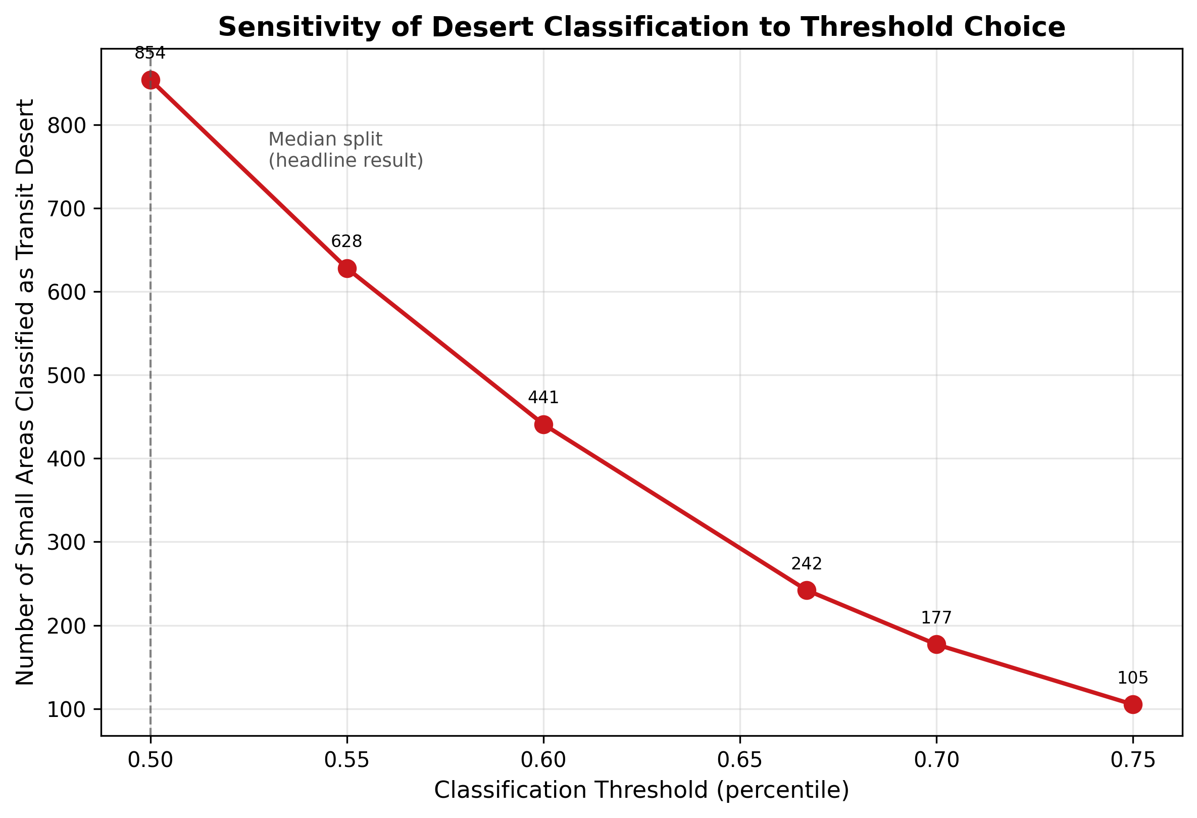
Figure 6. Desert count as a function of classification threshold (Table A plotted).

4.7 Spatial-Statistical Validation
A pattern of transit deserts identified by a demand-supply classification could, in principle, be spatially random noise rather than a genuine geographic phenomenon. To test this, Global and Local Moran's I statistics (Anselin, 1995) were computed on the Desert Severity Index using Queen contiguity spatial weights (each Small Area's neighbors defined as polygons sharing an edge or vertex; mean 5.9 neighbors per Small Area across the study area, no islands).
Global Moran's I tests whether the overall spatial pattern deviates from randomness: a value near zero indicates spatial randomness, positive values indicate clustering (similar values located near each other), and negative values indicate dispersion (dissimilar values located near each other). Local Moran's I (LISA — Local Indicators of Spatial Association) decomposes this into per-Small-Area cluster membership, classifying each area as part of a statistically significant High-High cluster (a desert surrounded by other deserts), Low-Low cluster (well-served, surrounded by other well-served areas), a spatial outlier (High-Low or Low-High), or not statistically significant, each evaluated at p < 0.05 using a 999-permutation conditional randomization test.

5.5 Spatial Clustering Validation
Global Moran's I for the Desert Severity Index was 0.679 (expected value under spatial randomness: −0.0002; z = 77.09; p = 0.001 across 999 permutations) — a strong, highly statistically significant positive spatial autocorrelation. This confirms that transit desert severity is not randomly distributed across the Dublin Region: deserts cluster geographically, consistent with an underlying, structural pattern (network topology, historical development patterns, or both) rather than statistical noise.
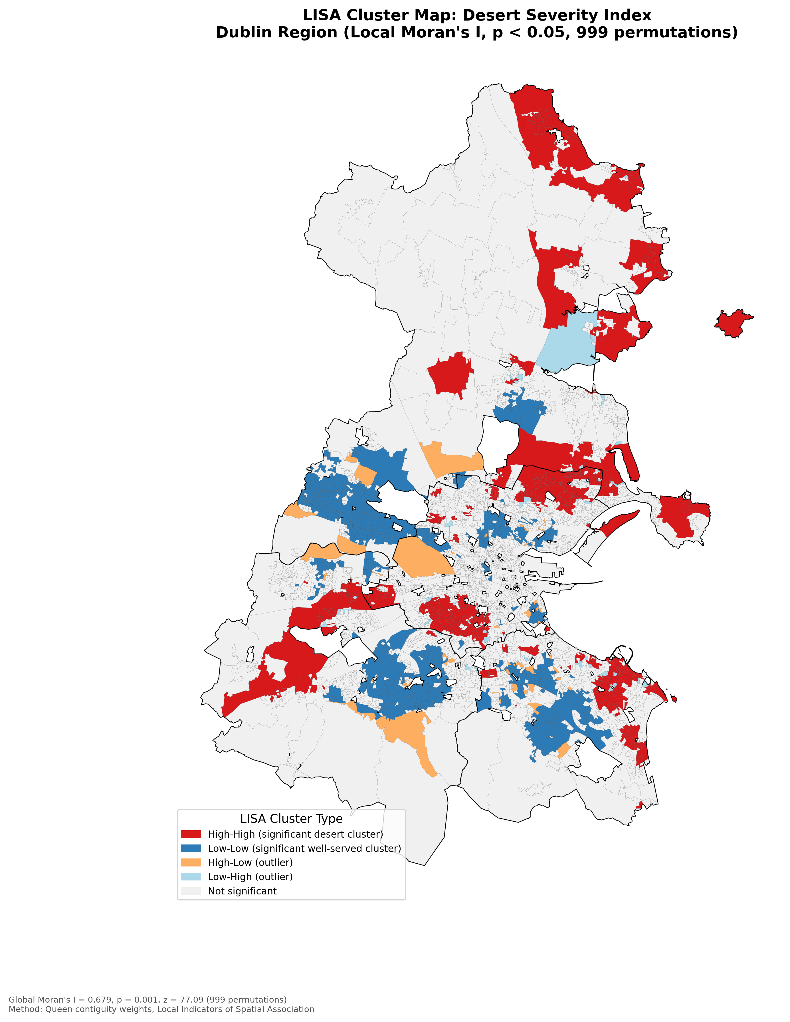
Figure 7. LISA cluster map — statistically significant (p < 0.05) High-High desert clusters and Low-Low well-served clusters.
LISA Cluster Type | Small Areas | % of Total
High-High (significant desert cluster) | 869 | 17.6%
Low-Low (significant well-served cluster) | 913 | 18.5%
High-Low (outlier) | 49 | 1.0%
Low-High (outlier) | 43 | 0.9%
Not statistically significant | 3,052 | 62.0%
Table 5. LISA cluster classification of the Desert Severity Index.
As a direct cross-check against the named priority zones in Section 7, all 46 Priorswood (B, C, D) Small Areas fall within a statistically significant High-High desert cluster (100%), and 57 of 77 Kimmage Small Areas do (74%). This confirms that the priority zones highlighted in this report are not artefacts of a top-N ranking exercise, but genuine, statistically validated spatial clusters — the same standard of evidence (Local Indicators of Spatial Association) commonly used in crash hotspot and disease cluster analysis.

5. Results: Employment Accessibility

5.1 Overall Classification
Of 5,076 Small Areas, 4,926 (97.0%) were classifiable (had both valid accessibility and census data). Under the median-split convention (Section 4.5), 854 (17.3% of classifiable areas) were classified as transit deserts, home to an estimated 233,825 people.
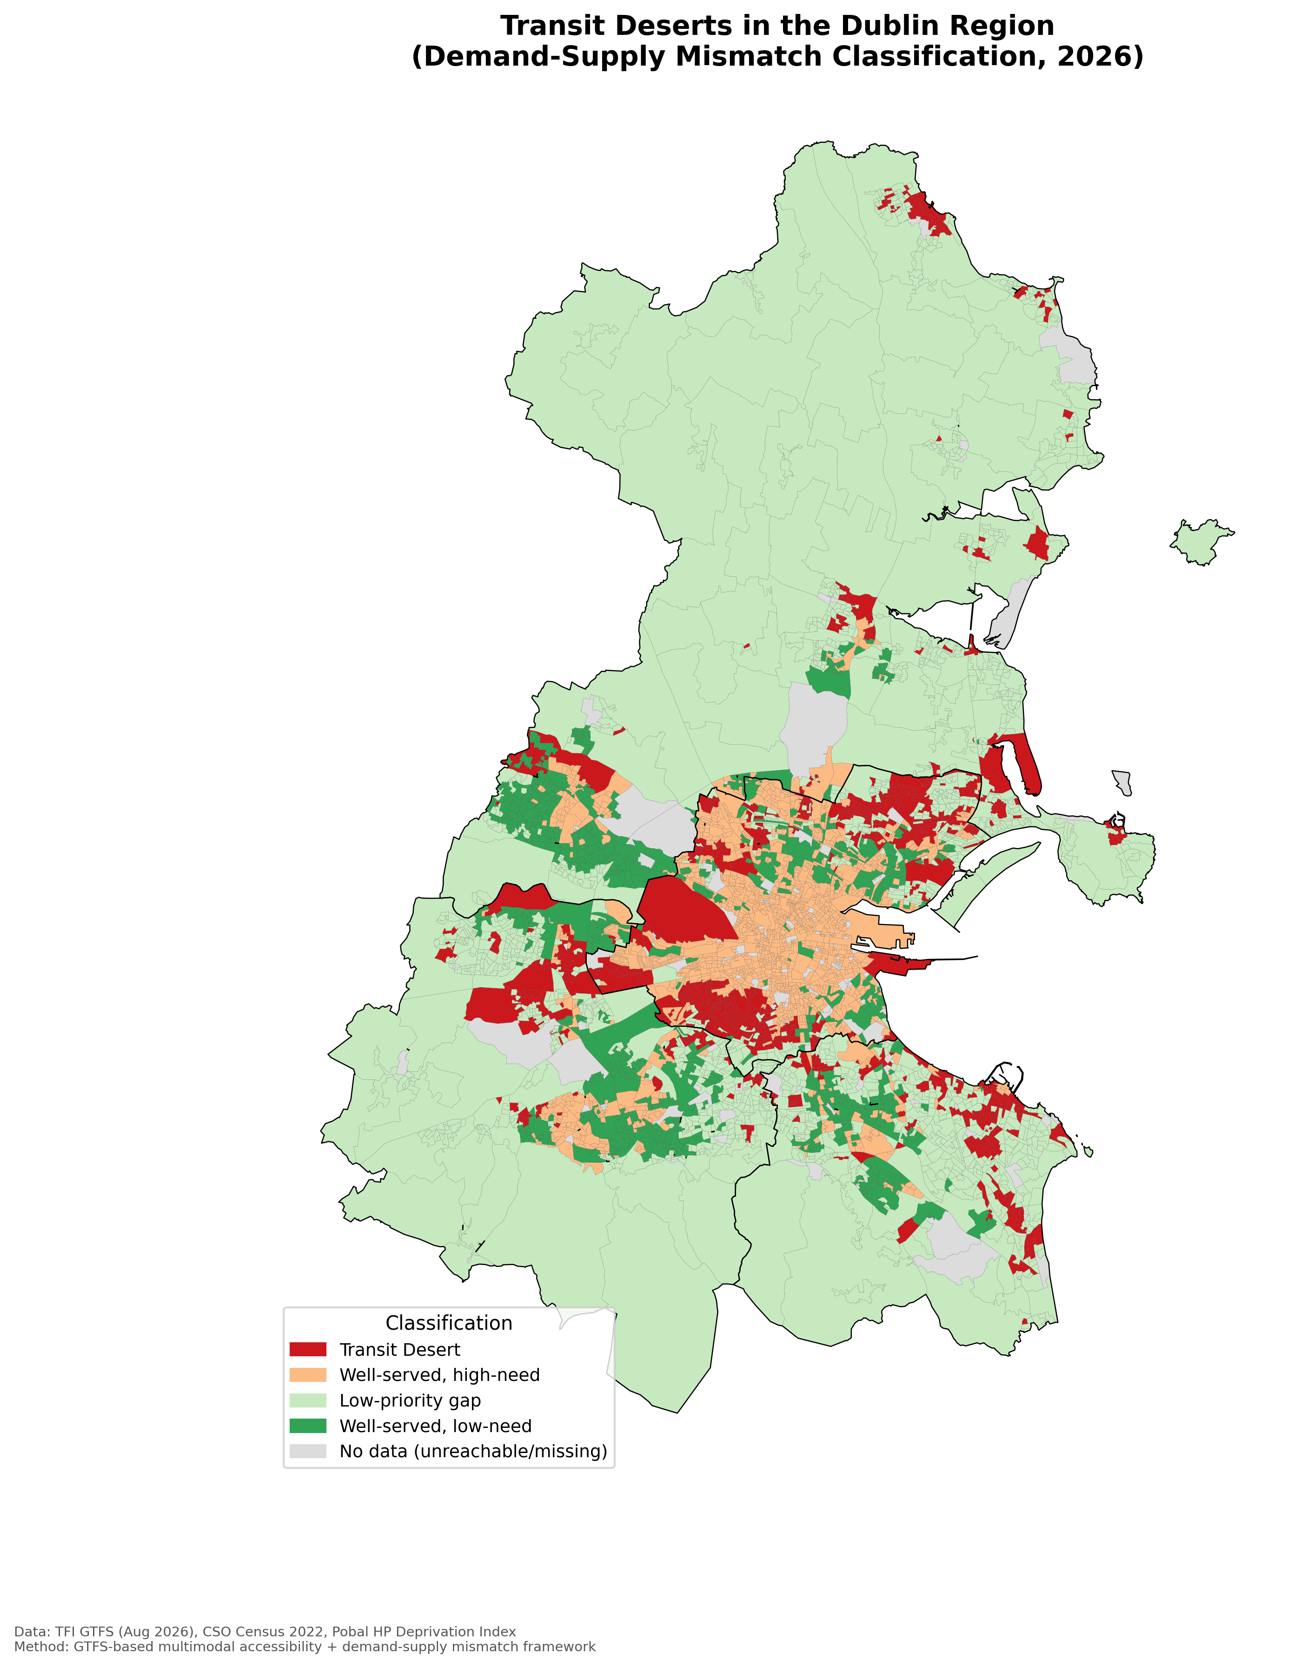
Figure 1. Transit desert classification, Dublin Region (demand-supply mismatch framework, median-split threshold).
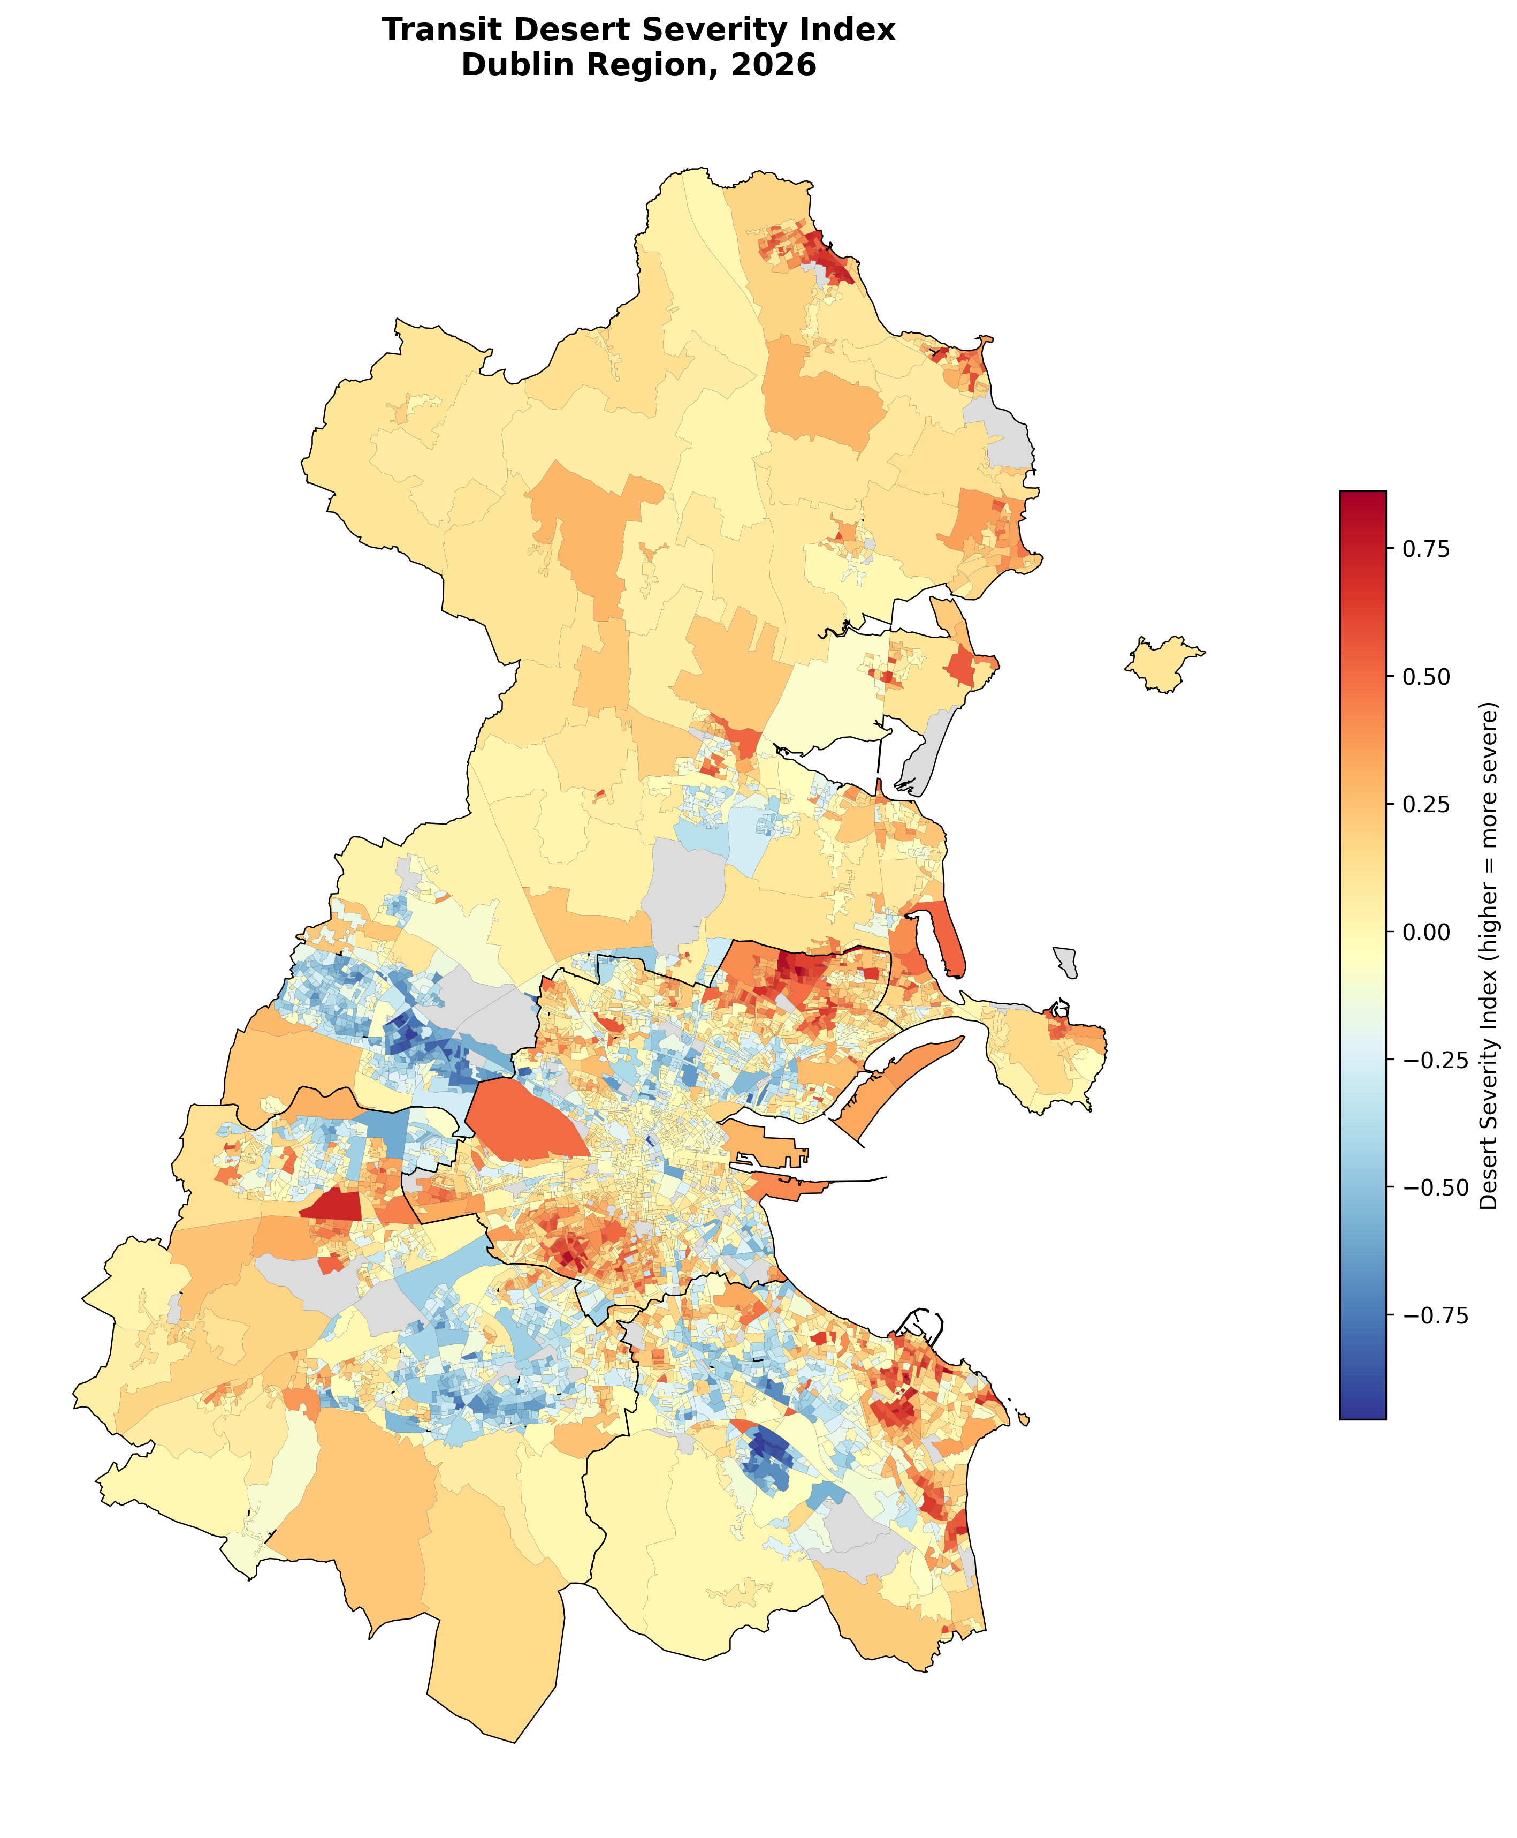
Figure 2. Continuous desert severity index. Notable severe clusters in north Fingal and the north-east inner city (Priorswood).

5.2 Underlying Variables
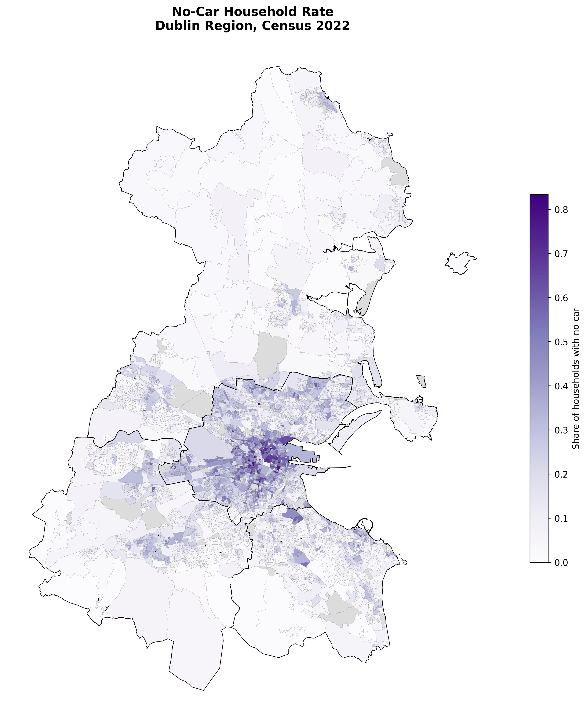
Figure 3. No-car household rate (NEED variable), Census 2022 — classic urban density gradient.
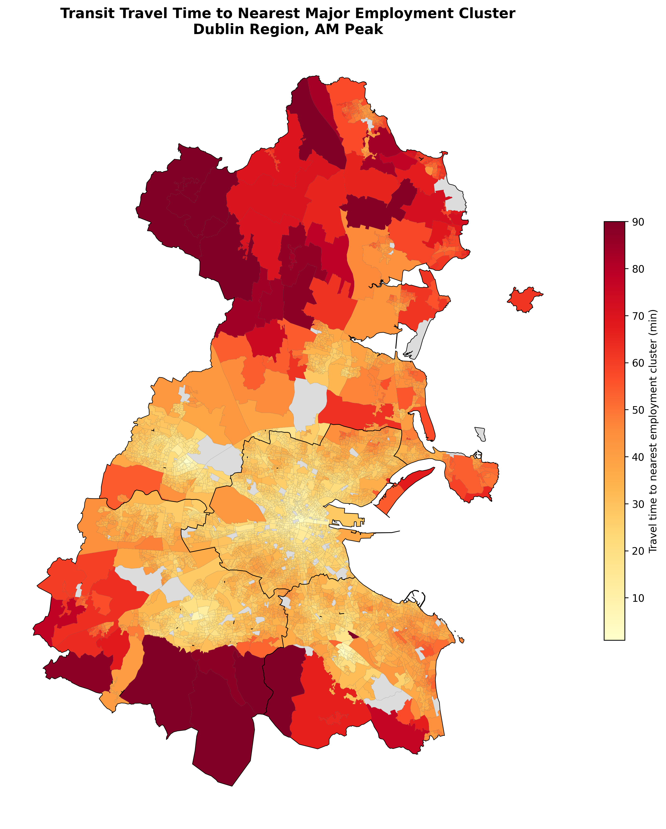
Figure 4. Travel time to nearest major employment cluster (ACCESS variable), AM peak.

5.3 Equity Statistics: Significance and Effect Size
A statistically significant association was found between desert status and Pobal deprivation category (χ² = 214.49, p < 0.001, df = 4, n = 4,926). Reporting the p-value alone, however, is insufficient at this sample size — with n approaching 5,000, even small effects reliably reach conventional significance thresholds. The corresponding effect size, Cramér's V, is 0.209, which by Cohen's (1988) conventional benchmarks (< 0.1 negligible, 0.1–0.3 small, 0.3–0.5 medium, > 0.5 large) falls in the small-to-moderate range.
The continuous correlation between desert severity and deprivation score was similarly modest: Pearson r = −0.190 (p < 0.001), Spearman ρ = −0.163 (p < 0.001) — both “small” effects under the same convention. Deprivation score is coded so that higher values indicate greater affluence, so the negative sign confirms deserts skew toward more deprived areas, but the modest magnitude is the substantively important finding: deprivation explains only a small share of variance in desert status. Transit deserts and income deprivation are statistically related but empirically distinct phenomena in this dataset — a result consistent with, and reinforcing, the rationale for using a dedicated demand-supply framework (Section 4.5) rather than deprivation alone as a screening tool.
Deprivation Category | Non-Desert SAs | Desert SAs | % Desert
Very Disadvantaged | 42 | 20 | 32.3%
Disadvantaged | 254 | 149 | 37.0%
Marginally Below Average | 751 | 250 | 25.0%
Marginally Above Average | 2134 | 296 | 12.2%
Affluent | 891 | 139 | 13.5%
Table 1. Desert status by deprivation category (χ² = 214.49, p < 0.001, Cramér's V = 0.21).

5.4 Electoral Divisions with 100% Desert Classification
Ten Electoral Divisions had every constituent Small Area classified as an employment-access transit desert under the median-split threshold:
ED | County | Small Areas | Deprivation Category
Priorswood B | Dublin City | 7 | Very Disadvantaged
Priorswood C | Dublin City | 16 | Disadvantaged
Priorswood D | Dublin City | 9 | Disadvantaged
Kimmage B | Dublin City | 14 | Marginally Below Average
Kimmage A | Dublin City | 7 | Marginally Below Average
Kimmage D | Dublin City | 10 | Marginally Above Average
Kilmore B | Dublin City | 11 | Disadvantaged
Kilmore C | Dublin City | 4 | Disadvantaged
Cherry Orchard A | Dublin City | 5 | Disadvantaged
Crumlin E | Dublin City | 10 | Marginally Below Average
Table 2. Electoral Divisions with 100% of Small Areas classified as employment-access transit deserts.

6. Multi-Purpose Accessibility Extension: Healthcare and Education
Section 3 identified employment-only focus as a gap in the existing Dublin literature: prior studies, including Ahern et al. (2016), model accessibility to employment but not to the healthcare and education destinations that matter disproportionately for non-commuting populations. This section addresses that gap directly.

6.1 Method
Hospital (n=62), school (n=682, after deduplication), and university/college (n=136) locations were extracted from the same OpenStreetMap extract used for the walk network (amenity=hospital, amenity=school, amenity=university/college tags respectively), snapped to the walk graph using the same technique as the employment destinations (median snap distances 17–28m across the three categories). Rather than searching from each individual facility separately, a multi-source Dijkstra search was used per category — finding “travel time to the nearest facility of this type” for every Small Area in a single graph traversal, rather than up to 693 separate searches. The same NEED variable (no-car-ownership rate) and the same median-split classification convention (Section 4.5) were applied to each category independently, keeping the equity lens consistent across destination types.

6.2 Results by Category
Category | Facilities (OSM) | Median Travel Time | Deserts (n) | % Classifiable
Employment (6 clusters) | 6 | 29.3 min | 854 | 17.3%
Hospital | 62 | 19.9 min | 743 | 15.1%
School | 682 | 8.4 min | 923 | 18.7%
University / College | 136 | 17.7 min | 620 | 12.6%
Table 3. Accessibility and desert classification by destination category.
Median travel times scale inversely with facility density, as expected: schools (the most numerous and spatially distributed category) show the shortest median access time, while hospitals and universities — more centralised facility types — show longer, more similar median times.

6.3 Compounding Disadvantage
The more analytically significant finding is not any single category in isolation, but the overlap between them. Each Small Area was scored on how many of the four categories (employment, hospital, school, university) it is classified as a transit desert for, ranging from 0 to 4.
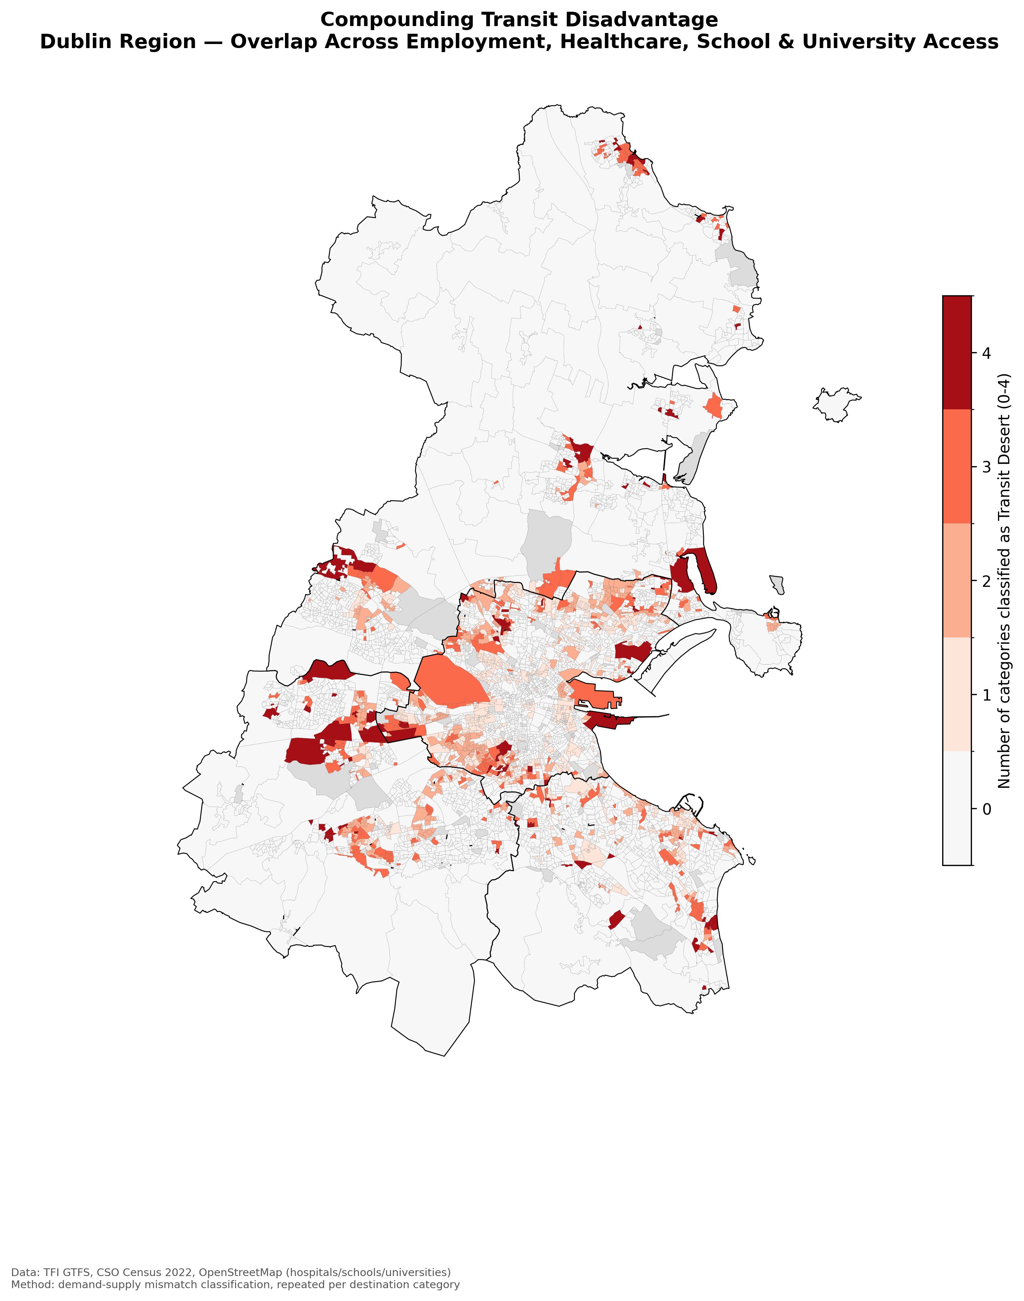
Figure 5. Compounding transit disadvantage — count of destination categories for which each Small Area is classified as a transit desert.
Categories Classified as Desert | Number of Small Areas
0 (not a desert for any category) | 3,352
1 | 632
2 | 451
3 | 358
4 (desert for every category tested) | 133
Table 4. Distribution of compounding desert classification across Small Areas.
491 Small Areas (10.0% of the 4,926 classifiable areas) are classified as transit deserts in three or more of the four categories tested — a pattern of compounding, not merely single-purpose, transit disadvantage. 133 Small Areas are classified as deserts across all four categories. These areas span all four Dublin local authorities: examples include Ballygall D, Rathmines East B, and Kimmage D (Dublin City); Tallaght-Jobstown, Lucan-St Helens, and multiple Clondalkin EDs (South Dublin); Balbriggan Rural and Baldoyle (Fingal); and Churchtown-Nutgrove (Dún Laoghaire-Rathdown). Notably, Cherry Orchard A and Kimmage D reappear here from the employment-only findings in Section 5.4, reinforcing that these specific areas face disadvantage across multiple, independent measures of transit access rather than a single-metric artefact.

7. Site-Specific Narratives

7.1 Priorswood (Dublin City, Coolock area)
Priorswood B, C, and D together account for 32 Small Areas, all classified as employment-access transit deserts, with two of the three EDs rated “Very Disadvantaged” or “Disadvantaged” on the Pobal index. Travel times to the nearest employment cluster (Dublin City Centre) range from 42–49 minutes despite Priorswood's location within Dublin City's administrative boundary — among the strongest, most internally consistent overlaps between transit disadvantage and deprivation found in this analysis, and a plausible candidate for a targeted BusConnects feeder-route intervention, though this report does not model the effect of any specific proposed route change.

7.2 Dún Laoghaire–Sandycove / Glenageary (Dún Laoghaire-Rathdown): A Last-Mile Case
Several Small Areas here rank among the most severe employment-access transit deserts in the entire dataset (severity index up to 0.86) despite direct DART rail access. Path-tracing confirms the routing correctly uses DART service (approximately 20 minutes in-vehicle, consistent with published DART timetables, with a short 1.6-minute modelled wait reflecting genuinely frequent peak service). The bottleneck is not the rail service itself but a last-mile transfer required at the Dublin end: the nearest employment cluster (IFSC/Docklands) requires an additional bus connection beyond the DART arrival station. This finding is consistent with Oeschger, Carroll and Caulfield's (2023) emphasis on first/last-mile walking access and egress as a material, independent determinant of accessibility — trunk-line rail proximity does not, by itself, guarantee door-to-door accessibility if destination-end connectivity is poor.

7.3 Kimmage (Dublin City)
Kimmage A, B, and D show 100% employment-access desert classification, with travel times of 38–41 minutes to nearest employment clusters (Tallaght and city centre) despite Kimmage's relatively central location, suggesting an orbital/cross-city connectivity gap rather than a peripheral access problem. Kimmage D also appears in the compounding-disadvantage list (Section 6.3), indicating this area's transit gap is not employment-specific.

7.4 Balbriggan Rural (Fingal)
Represents the north Fingal severity cluster visible in Figure 2, with travel times exceeding 56 minutes to the nearest employment cluster — consistent with its position at the northern edge of the Dublin Region, and a genuine peripheral-access story distinct from the inner-city pattern seen in Priorswood and Kimmage. Balbriggan Rural also appears among the four-category compounding-disadvantage areas (Section 6.3).

8. Discussion
Four distinct disadvantage typologies emerge from this analysis, each implying a different intervention logic:
- Inner-city orbital gaps (Priorswood, Kimmage, Kilmore, Cherry Orchard): high deprivation overlap, suggesting targeted feeder-route or orbital-bus investment under BusConnects would directly serve populations already identified as vulnerable on independent equity grounds.
- Last-mile-at-destination gaps (Dún Laoghaire/Sandycove): strong trunk rail access undermined by poor onward connectivity at the destination end — suggesting city-centre circulator or last-mile service, not radial investment, is the relevant intervention.
- Peripheral/edge-of-region gaps (Balbriggan Rural and similar): genuine distance-based disadvantage, where the policy question is regional service frequency rather than local network topology.
- Compounding-disadvantage areas (Section 6.3): Small Areas facing poor access across employment, healthcare, and education simultaneously — arguably the highest-priority category for intervention, since residents here cannot substitute one trip purpose's relatively better access for another's deficiency.
The modest effect size linking desert severity to deprivation (Cramér's V = 0.21, Pearson r = −0.19; Section 5.3) is itself a substantive finding, not merely a statistical footnote: it indicates that using income deprivation alone as a proxy for transit need — as Ahern et al.'s (2016) original framework effectively did, and as many transport equity screening exercises still do — would miss a meaningful share of the areas this analysis identifies as genuinely underserved, including the entire Dún Laoghaire/Sandycove cluster, which the Pobal index classifies as “Affluent” to “Marginally Above Average.” This supports the case for a dedicated demand-supply mismatch framework, evaluated across multiple destination purposes, over deprivation-only screening in transport planning contexts — while stopping short of claiming the deprivation-based approach is wrong, only that it is incomplete on this evidence.
The spatial-statistical validation (Section 5.5) adds a further layer of confidence to these typologies: the desert pattern is not an artefact of independent, spatially uncorrelated classification noise, but a strongly clustered phenomenon (Global Moran's I = 0.679, p = 0.001). This matters practically as well as statistically — a genuinely clustered desert pattern is actionable for targeted infrastructure investment (a feeder route can plausibly serve an entire contiguous cluster), whereas a spatially random pattern of “desert” classifications scattered without geographic coherence would be far harder to address with any single intervention.

9. Limitations
- Employment destination points (Section 5) are hand-specified approximations of six major Dublin employment clusters, not a comprehensive jobs-weighted surface — reflecting the absence of open, fine-grained workplace-location data for Ireland at Small Area level.
- Deprivation data ceiling. The Pobal HP Deprivation Index is only openly available at Electoral Division level; Small Area-level deprivation data exists but is licensed to its authors (Haase & Pratschke) and was not accessible for this study. Deprivation comparisons in this report are therefore at coarser resolution than the accessibility layer, and the equity statistics in Section 5.3 inherit this resolution mismatch.
- Geometric, not population-weighted, centroids are used throughout (Section 4.4), due to the lack of open sub-Small-Area population density data for Ireland.
- The no-car-ownership variable's denominator includes an average 8.9% “not stated” response share (Section 4.2.1), which is not corrected for and may bias the reported rate conservatively if non-response correlates with actual car ownership status.
- 147 Small Areas (2.9%) sit on small, disconnected islands within the OSM walk network — likely missing footway links in OpenStreetMap's crowdsourced data — and could not be scored for employment accessibility (a similar, though not identical, count of ~139-146 Small Areas is affected per category in the multi-purpose extension).
- A single representative weekday (Wednesday) and the AM peak period were used as the primary analysis scenario; PM peak and off-peak results were computed during the pipeline build but are not the focus of this report.
- Scheduled, not observed/real-time, travel times are used throughout — the analysis reflects the published GTFS timetable, not actual vehicle performance, and does not account for delays, cancellations, or overcrowding-driven pass-ups.
- Twelve stop-period combinations (out of approximately 26,800) show a headway of exactly zero seconds, caused by overlapping GTFS trip variants scheduled to depart the same stop at the identical minute — a narrow source-data quirk with negligible effect on aggregate results.
- The classification threshold (median split) is a convention; Section 4.6 reports sensitivity across six alternative thresholds, and the headline 17.3% figure should be read in that context, not as an absolute count.
- The literature review (Section 2) reflects a targeted, not systematic, search; no claim of research priority is made in this report (see Appendix).
- Exact GTFS feed producer URL and content hash were not recorded at download time (Section 4.2); this is identified as a specific fix required before formal citation or journal submission.

10. Conclusion & Recommendations
This study presents an open, reproducible, GTFS-based transit desert analysis of the Dublin Region's current public transport network, identifying 854 Small Areas (233,825 people) as employment-access transit deserts under a median-split demand-supply mismatch framework, and 133 Small Areas as deserts across employment, healthcare, and education access simultaneously. Four distinct disadvantage typologies were identified, each warranting a different planning response: targeted feeder/orbital investment in inner-city clusters with high deprivation overlap; last-mile circulator service at high-employment destinations for otherwise well-served rail corridors; continued regional service frequency investment for peripheral areas; and priority attention to the 133 compounding-disadvantage areas facing poor access across every purpose tested.
Recommended next steps for this research programme:
- Resolve the reproducibility gaps identified in the Publication-Readiness Appendix (below) before any formal citation, journal submission, or use in a planning decision context.
- Investigate the ~140-150 disconnected Small Areas' underlying OSM walk network gaps per category, potentially contributing corrections back to OpenStreetMap.
- Extend the analysis to PM peak and weekend/off-peak scenarios, already computed in the underlying pipeline but not reported here, to test whether the desert pattern is time-of-day dependent.
- Pursue access to Small Area-level Pobal deprivation data to remove the current ED-level resolution ceiling on the equity comparison.
- Where feasible, validate scheduled travel times against GTFS-Realtime or observed AVL data for a sample of routes, to quantify the scheduled-vs-observed gap noted in Section 9.

Appendix: Publication-Readiness Checklist
This analysis was reviewed against standards appropriate for formal academic or professional citation. The table below documents each identified issue and its resolution status in this version of the report.
# | Issue | Status in This Revision
1 | Inconsistent use of “Greater Dublin Area” for the four-authority study extent | Resolved — “Dublin Region” used consistently throughout (Section 1); GDA reserved for the wider planning concept
2 | Contradiction between “population-weighted” and “geometric” centroid claims | Resolved — confirmed against the actual pipeline: geometric centroids are used throughout (Section 4.4); prior draft's methodology section incorrectly stated population-weighting
3 | No-car variable definition and denominator undocumented | Resolved — exact numerator/denominator, composition, and “not stated” share documented (Section 4.2.1)
4 | GTFS feed URL, download date, version/hash undocumented | Partially resolved — source, download date, and service date range documented (Section 4.2); exact producer URL and content hash were not recorded at download time and are flagged as an outstanding fix
5 | Desert Severity Index lacked formal mathematical definition and tie-handling documentation | Resolved — explicit formula and tie-handling convention documented (Section 4.5)
6 | No sensitivity analysis for classification threshold | Resolved — six-threshold sensitivity table and chart added (Section 4.6, Table A, Figure 6); core priority areas confirmed robust to threshold choice
7 | Statistical significance reported without effect size | Resolved — Cramér's V and Cohen's (1988) interpretive benchmarks added alongside all significance tests (Section 5.3)
8 | Unqualified “first” claim without documented systematic search | Resolved — priority language removed from Executive Summary and Conclusion; literature review explicitly labelled as targeted, not systematic (Sections 2, 3, 9)
9 | No spatial-statistical robustness test | Resolved — Global and Local Moran's I (LISA) computed on the Desert Severity Index using Queen contiguity weights, 999-permutation significance testing (Section 4.7, 5.5); confirms strong, statistically significant spatial clustering (I = 0.679, p = 0.001) and validates named priority zones as genuine clusters, not ranking artefacts
10 | Numerical outputs not independently re-validated against final pipeline | Resolved — all headline figures (desert counts, population, chi-square, Cramér's V) independently re-derived from source data files and confirmed to match this report exactly, with zero discrepancies found
Outstanding item before formal submission: recover or re-derive the exact GTFS feed producer URL and a content hash (e.g. SHA-256 of the downloaded zip) for full bitwise reproducibility. This was not captured during the original data acquisition session and cannot be reconstructed retroactively without re-downloading and cross-referencing the Mobility Database's dataset history for the relevant date.

References
Ahern, A., Vega, A., & Caulfield, B. (2016). Deprivation and access to work in Dublin city: The impact of transport disadvantage. Research in Transportation Economics, 57, 44–52. https://doi.org/10.1016/j.retrec.2016.06.009
Chen, N., & Jiao, J. (2022). Are there transit deserts in Europe? A comparative study of Grand Paris, Madrid, and Greater London. Sustainability.
Jiao, J., & Dillivan, M. (2013). Transit deserts: The gap between demand and supply. Journal of Public Transportation, 16(3).
Oeschger, G., Carroll, P., & Caulfield, B. (2023). First and last-mile connections to public transport in Dublin. (ScienceDirect).
National Transport Authority (Ireland) (2025). Transport equity and accessibility: A logsum-based distributional analysis.
Transport Insights / Systra (2016). South Dublin County Council Public Transport Accessibility Review.
Haase, A., & Pratschke, J. Pobal HP Deprivation Index, 2022 update.
Central Statistics Office (Ireland). Census 2022 Small Area Population Statistics.
Transport for Ireland (National Transport Authority). Static GTFS schedule feed, accessed via Mobility Database, August 2026.
Cohen, J. (1988). Statistical Power Analysis for the Behavioral Sciences (2nd ed.). Lawrence Erlbaum Associates.
Anselin, L. (1995). Local Indicators of Spatial Association — LISA. Geographical Analysis, 27(2), 93–115.

